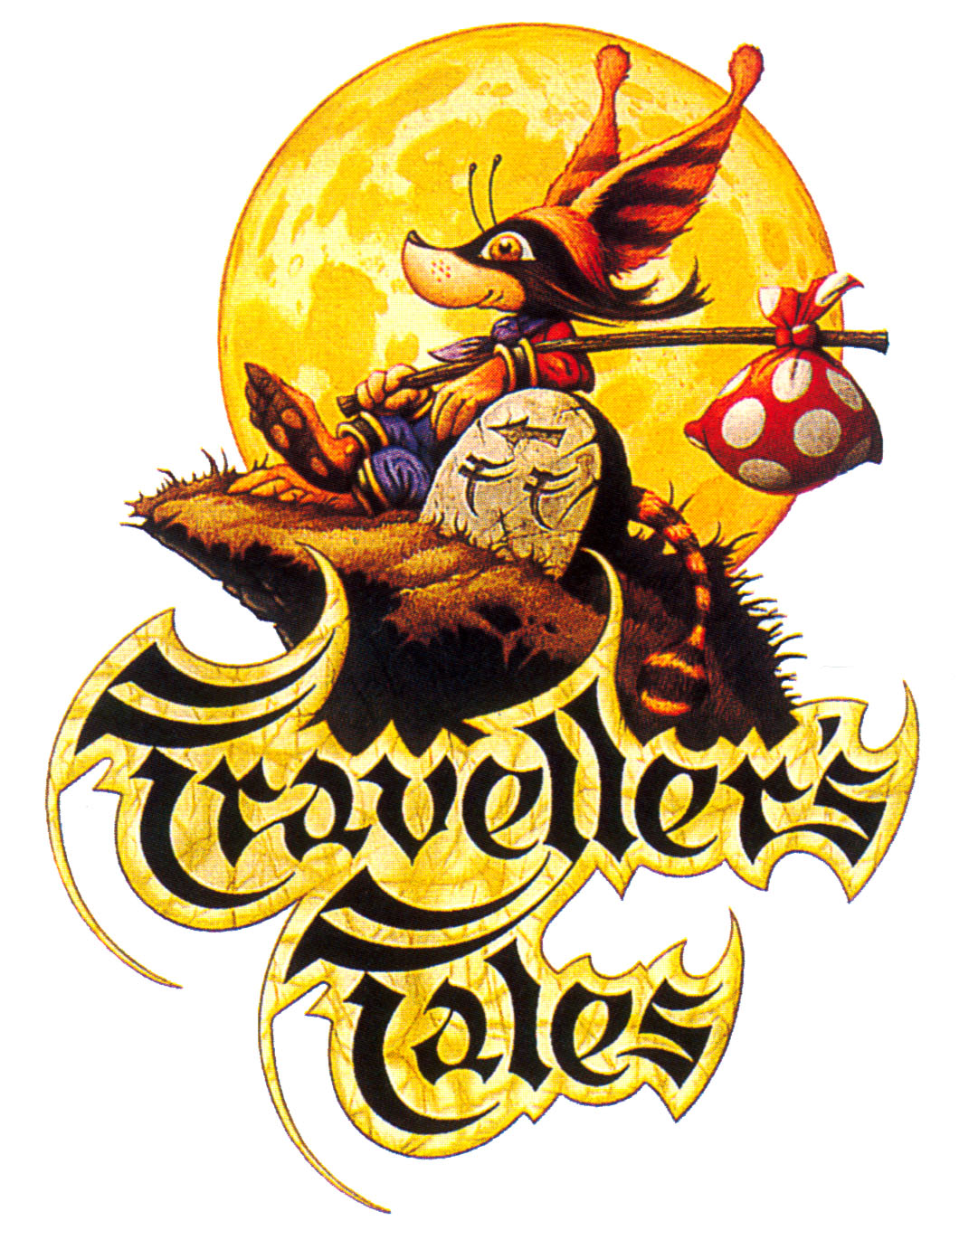

Biography

Travellers Tales (UK) Ltd
The Brookdale Centre
Bluebell Stables
Manchester Road
Knutsford
Cheshire
WA16 0SR
Overview

Formed in 1989, Travellers Tales now have offices in both Knutsford and Oxford and employ a total of 85 people. We currently have a total of 4 teams, each working on separate projects and we also have a strong technology and research department that is currently developing a PSP engine, as well as restructuring and expanding our current technology to embrace the new generation of console hardware.

Traveller’s Tales has always designed its games around a very portable API, which allows ports of the games to be up to date on each console in under a day. Each individual console team is encouraged to push the limits of their hardware renderer and any enhancements are re-integrated into the engine to benefit all products.

Latest Development Information:
- We have recently finished developing Crash 6: Twinsanity for PS2 and XBOX in our Oxford office.
- We are just mastering Lego: Star Wars for PS2, XBOX and PC in Knutsford
- We are developing Formula 1/World Rally Championship for Sony PSP in Knutsford (using Assets from the PS2 versions)
- We are developing The Chronicles of Narnia for Disney, due for release of the movie of the same name for Christmas ’05 for PS2, XBOX, GC, PSP and PC
Softography

Title Units (To Date) Genre
Leander (AM) 27,000 Platform
Puggsy (MD/MCD) 138,200 Platform
Bram Stoker’s Dracula (MD/SNES) 100,000 Platform
Mickey Mania (MD/SNES/MCD/PSX) 2,442,821 Platform
Toy Story (MD/SNES) 1,700,000 Platform
Sonic 3D (MD/SA/PC) 1,468,652 Platform
Sonic R (SA/PC) 851,665 Racing
Rascal (PSX) 548,554 Platform
A Bug’s Life (PSX/N64/PC) 3,335,503 Platform
Toy Story 2 (PSX/N64/PC/DC) 2,768,785 Platform
Muppet Racemania (PSX) 146,764 Cart Racing
Buzz Lightyear (PSX/PC/GBC/DC) 938,770 Platform/Shooting
Toy Story Racer (PSX) 246,181 Cart Race
Weakest Link (PSX/PS2/PC) 667,412 Quiz
Crash: Wrath of Cortex (PSX/XBOX) 5,463,906 Platform
Haven (PS2) 311,822 Multi-Genre
Wreckless (PS2) 206,337 Driving
Finding Nemo (PS2/XBOX/GC) 3,000,899 Platform
A Total of 18 games and 40 SKU’s

Key:
Amiga – AM MegaDrive – MD Mega CD – MCD
Super Nintendo – SNES Playstation – PSX Nintendo 64 – N64
Saturn – SA Playstation 2 – PS2 DreamCast – DC
Gamecube – GC

Of the known sales figures we have sold a total of over 24,588,000 units.

In the last 7 years we have had 11 games sell over 500,000 units. Seven of those sold over 1,000,000 units, and five of those sold over 2,000,000 units.

Every game we have produced has been delivered and approved on time (mainly due to film tie in dates)

